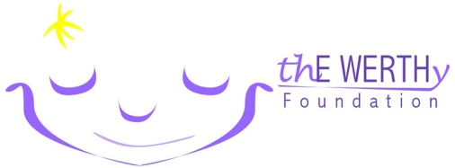
thE WERTHy Foundation Golf Outing

___________________________________________________ ___________________________________________________
Company/Individual Name Phone Number

___________________________________________________ ___________________________________________________
Authorized Representative E-mail

Please indicate your 2016 sponsorship level:

Platinum Level: $1000 ________
- Participation for (4) golfers in thE WERTHy Golf Outing (Welcome package, breakfast and lunch)
- Exclusive signage at welcome breakfast and post golf lunch
- Sponsor board display
- Recognition in welcome package

Gold Level: $500 ________
- Company logo displayed on one Par-3 ”Event Hole”
- Sponsor Board Display
- Recognition in welcome package

Silver Level: $250 ________
- Company logo displayed on a “Specialty Food & Beverage Oasis”
- Sponsor Board Display
- Recognition in welcome package

Bronze Level: $100 ________
- Company logo displayed on Tee Box
- Sponsor Board Display
- Recognition in welcome package

Other Amount: $ ___________ Donation of Raffle Prize ___________________
_______________________________________________________________________________________________________________________________________
Check payable to: thE WERTHy Foundation
Mail to:
thE WERTHy Foundation Golf Outing
237 S. Wildrose Ct., Round Lake, IL 60093

Credit Card Visa MasterCard Discover

Card #____________________________________ Exp Date__________

Authorized Signature_________________________ Date_____________

Paypal – lyle@thewerthy.org

Please submit your completed form no later than May 20, 2016
Questions? Contact Lyle Werth - lyle5@comcast.net

