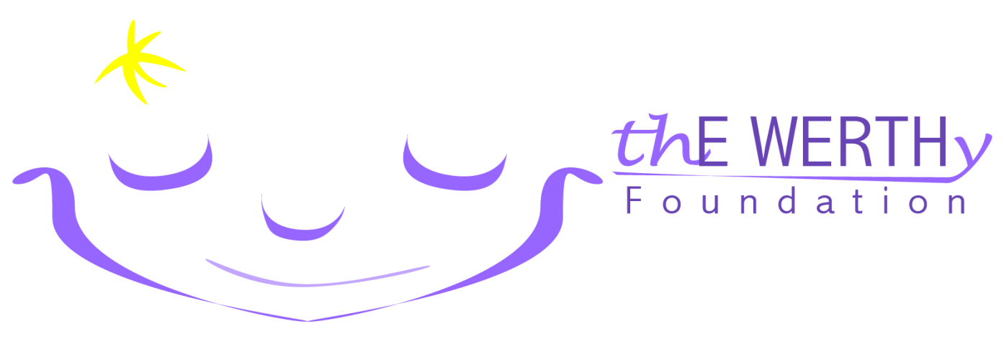

thE WERTHy Foundation has been set up in honor of Erin Werth to assist in the care of children dealing with seizures and epilepsy.

Mission Statement
"Through our network of family and friends, provide additional resources to facilities and institutions who aid in seizure/epilepsy care as well as families with a child who is dealing with seizures/epilepsy."

Erin’s Inspiration
Erin was born in July 2000 and began having seizures when she was about 3 months old. While she continues to grow physically, developmentally she never surpassed the 4 month plateau. Erin requires continuous care, is non weight bearing, wheelchair bound and does not speak or sit up. She has a Vagus Nerve Stimulator (VNS) device and is tube fed. She has been through hundreds of tests and to this day, the only diagnosis is Epilepsy.

Impact on…
Care
Erin has had numerous hospital stays which have included surgeries, many ambulance rides and even a flight for life helicopter ride when she was less than a year old. We have been lucky that our insurance has covered most of our bills, but we know others with similar experiences who are a lot less fortunate.
Education and therapy
Erin has been blessed by having very dedicated teachers and therapists who spend countless hours working with her to develop a method of simple communication so she can express her basic needs and wants. We have come to understand how much time and effort facilities such as Erin’s school put into therapy, teaching and adapting ideas that are designed specifically for children like Erin.

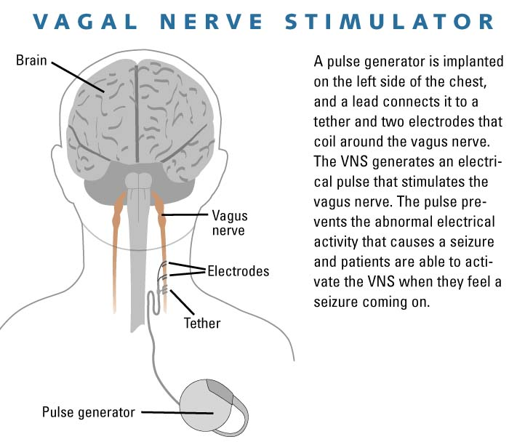

Goals
thE WERTHy Foundation’s initial goal is to provide some assistance to facilities and institutions that deal in the care of children with seizures/epilepsy with a longer range goal of aiding families who have a child with seizures/epilepsy. Our hope is that we can provide practical items such as wheelchairs, medical equipment, educational tools or even adaptation equipment within the house vs. solely monetary donations.

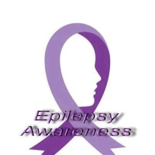
Beliefs
We believe that with our strong network of family and friends and with the support of the communities in which we live and work we can all make a difference in the lives of those impacted by childhood epilepsy and seizures. The operation of this foundation will be dedicated to making that difference.

Contact, Legal and Tax Information
The foundation is a legal entity (EIN# 46-2665790) and is a legal 501(c)(3) organization.
Contact us: info@thewerthy.com or find us on Facebook. Thanks for your support.

