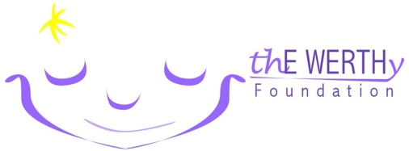

thE WERTHy Foundation Golf Outing
Friday May 24th, 2019
Donation Includes
18 holes of Golf
Cart
Breakfast/Lunch
Goody Bag
Prizes for:
Longest Drive
Closest to Pin
Longest Putt
Chalet Hills Golf Club
943 Rawson Bridge Road,
Oakwood Hills, IL 60013
Check in
7:30 – 8:45
Breakfast
7:30 – 9:00
Tee Off
9:00 Shotgun
Lunch Approx.
1:30
Awards & Raffle
Follow lunch

Donation of $150 per person due with registration
SINGLES WELCOME!! We will team you up!

REGISTER BY MAY 13th, $150 / Person

Please make checks payable to: thE WERTHy Foundation

Mail to:
thE WERTHy Foundation Golf Outing
237 S. Wildrose Ct.
Round Lake, IL 60073

For more information contact: Lyle Werth 847-508-2240 email lyle5@comcast.net

NAME: ______________________________ ___ I have enclosed a check in the amount of _____
COMPANY: __________________________ ___ please charge my credit card in the amount of _____
ADDRESS: ___________________________ Name on card: _____________________ Zip Code: _____
____________________________________ Card type please circle: MASTERCARD VISA DISCOVER
PHONE: _____________________________ CARD NUMBER: _______________ EXP ____ Sec Code ____
REGISTER ONLINE HERE ____ PayPal: lyle@thewerthy.org
PLAYER 1
NAME _________________________________________ PHONE _________________________ EMAIL ____________________________

PLAYER 2
NAME _________________________________________ PHONE _________________________ EMAIL ____________________________

PLAYER 3
NAME _________________________________________ PHONE _________________________ EMAIL ____________________________

PLAYER 4
NAME _________________________________________ PHONE _________________________ EMAIL ____________________________

