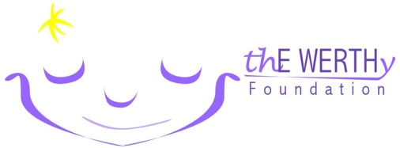

thE WERTHy Foundation Golf Outing

___________________________________________________ ___________________________________________________
Company/Individual Name Phone Number

___________________________________________________ ___________________________________________________
Authorized Representative E-mail

Please indicate your 2019 sponsorship level:
(All sponsorship levels will be mentioned on sponsor board and be recognized in welcome package)

Platinum Level: $1000 ________
- Participation for (4) golfers in thE WERTHy Golf Outing (Welcome package, breakfast and lunch)

Gold Level: $500 ________
- Company logo displayed on one Par-3 ”Hole-in-One” Prize Holes

Silver Level: $250 ________
- Company logo displayed on a “Golf Carts”

Bronze Level: $100 ________
- Company logo displayed on Tee Box

Donation of Goodie Bag Item: ___________ Donation of Raffle Prize ______________

_______________________________________________________________________________________________________________________________________
Check payable to: thE WERTHy Foundation
Mail to:
thE WERTHy Foundation Golf Outing
237 S. Wildrose Ct., Round Lake, IL 60073

Credit Card Visa MasterCard Discover

Card #____________________________________ Exp Date__________ Security Code_______

Authorized Signature_________________________ Date_____________ Zip Code _____________

Paypal – lyle@thewerthy.org

Please submit your completed form no later than May 13, 2019
Questions? Contact Lyle Werth - lyle5@comcast.net

