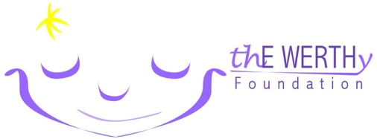

thE WERTHy Foundation Golf Outing
Friday May 22th, 2020
Donation Includes
18 holes of Golf
Cart
Breakfast/Lunch
Goody Bag
Prizes for:
Longest Drive
Closest to Pin
Longest Putt
Hole-in-One
Chalet Hills Golf Club
943 Rawson Bridge Road,
Check in
7:30 – 8:45
Breakfast
7:30 – 9:00
Tee Off
9:00 Shotgun
Lunch Approx.
1:30
Awards & Raffle
Follow lunch
Oakwood Hills, IL 60013

Player Packages:
Title Sponsor - $3000 includes foursome (see sponsor form)
Ace Sponsor - $1500 includes foursome (see sponsor form)
Individual player - $175/person

SINGLES WELCOME!! We will team you up!
REGISTER BY MAY 15th, $175 / Person

Please make checks payable to: thE WERTHy Foundation

Mail to:
thE WERTHy Foundation Golf Outing
237 S. Wildrose Ct.; Round Lake, IL 60073

For more information contact: Lyle Werth 847-508-2240 email lyle5@comcast.net

NAME: ______________________________ ___ I have enclosed a check in the amount of _____
COMPANY: __________________________ ___ please charge my credit card in the amount of _____
ADDRESS: ___________________________ Name on card: _____________________ Zip Code: _____
____________________________________ Card type please circle: MASTERCARD VISA DISCOVER
PHONE: _____________________________ CARD NUMBER: _______________ EXP ____ Sec Code ____
____ PayPal: lyle@thewerthy.org
PLAYER 1
NAME _________________________________________ PHONE _________________________ EMAIL ____________________________

PLAYER 2
NAME _________________________________________ PHONE _________________________ EMAIL ____________________________

PLAYER 3
NAME _________________________________________ PHONE _________________________ EMAIL ____________________________

PLAYER 4
NAME _________________________________________ PHONE _________________________ EMAIL ____________________________

